BCPS Service and Retirement Recognitions
5 YEARS
Ryan Borden
Dinah Johnson
Marta Szychowska-Cauley

10 YEARS
Suzanna Paxton
Steve Sweitzer
Brett Moyers

15 YEARS
Mark Cook
Joyce Lewis

20 YEARS
Kimberly Manion

25 YEARS
Kristy Pasco
Betty Bradberry

35 YEARS
Jane McMullen

50 YEARS
David Watkins

RETIREMENT
Ron Shifflett - 7 years
Paul Dean - 36 years
Debbie Chaplin - 43 years
David Watkins - 50 years

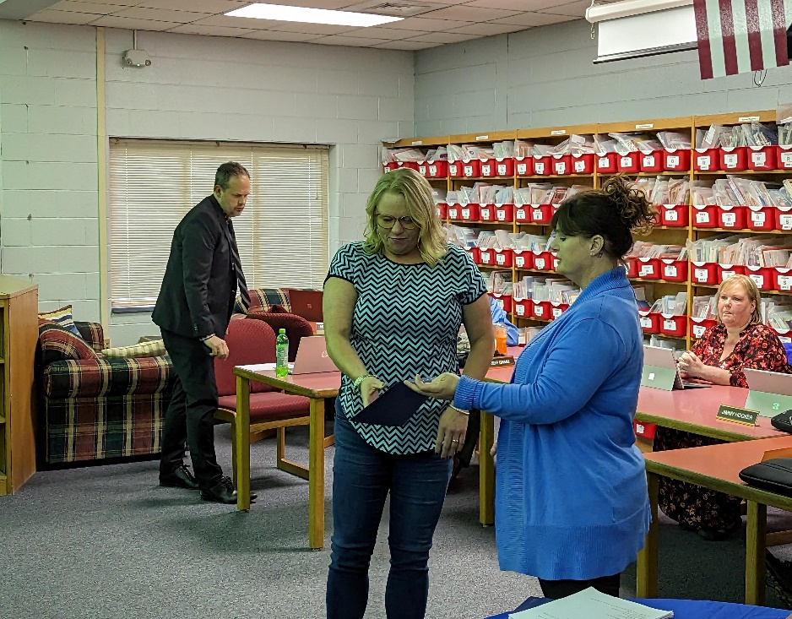
Mrs. Moyers
10 Years
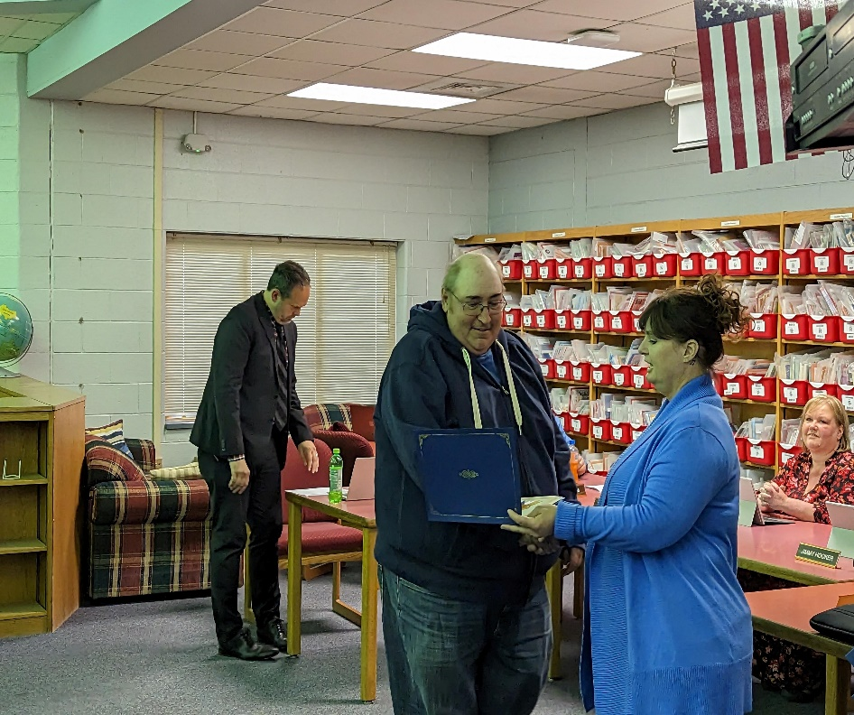

Mr. Sweitzer
10 Years

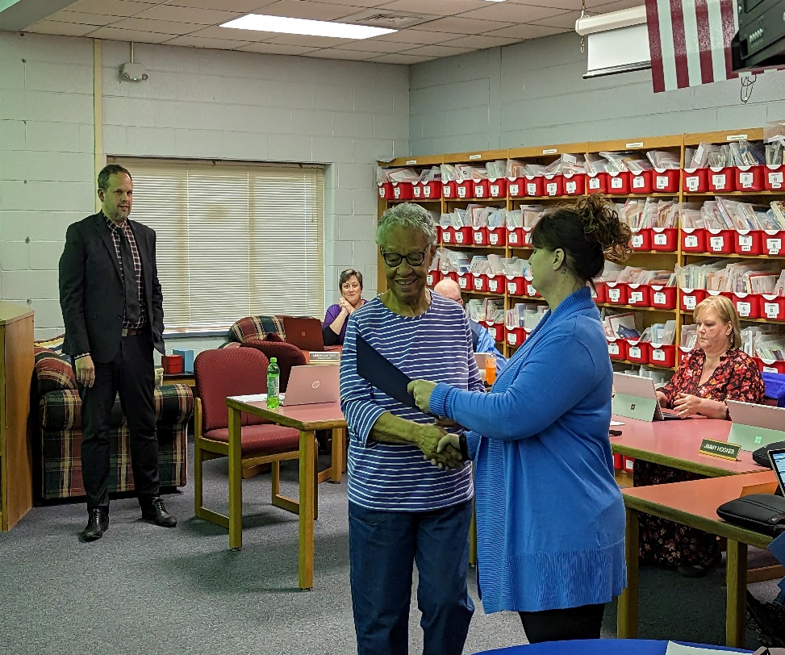

Mrs. Lewis
15 Years
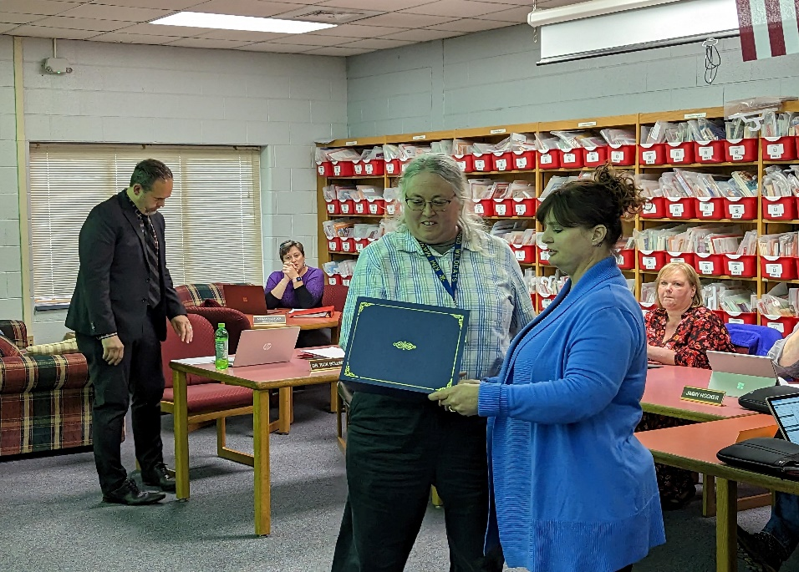
Ms. Manion
20 Years

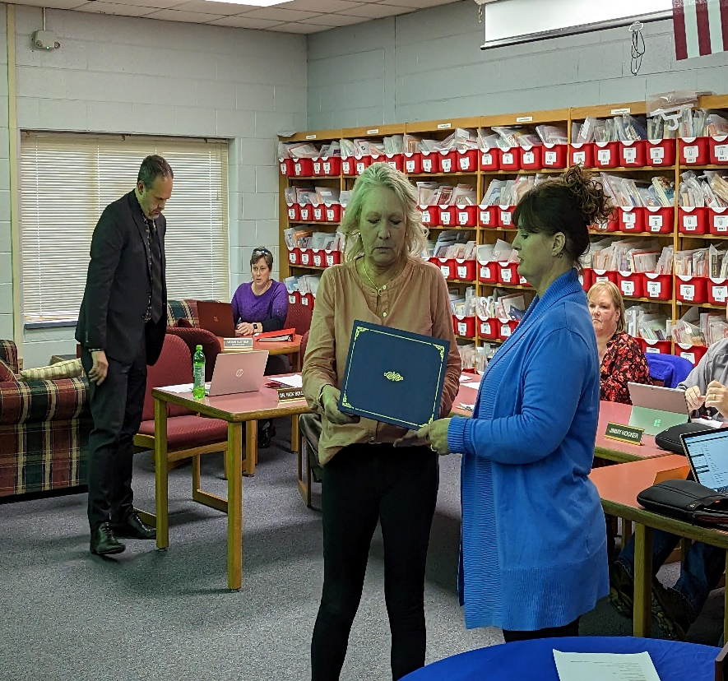
Mrs. McMullen
35 Years
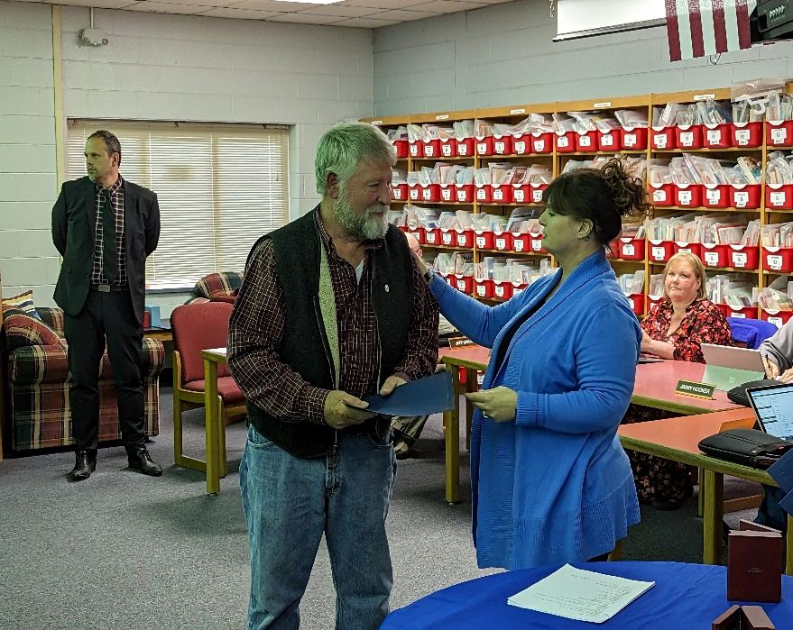
Mr. Shifflett
Retiring After 7 Years of Service

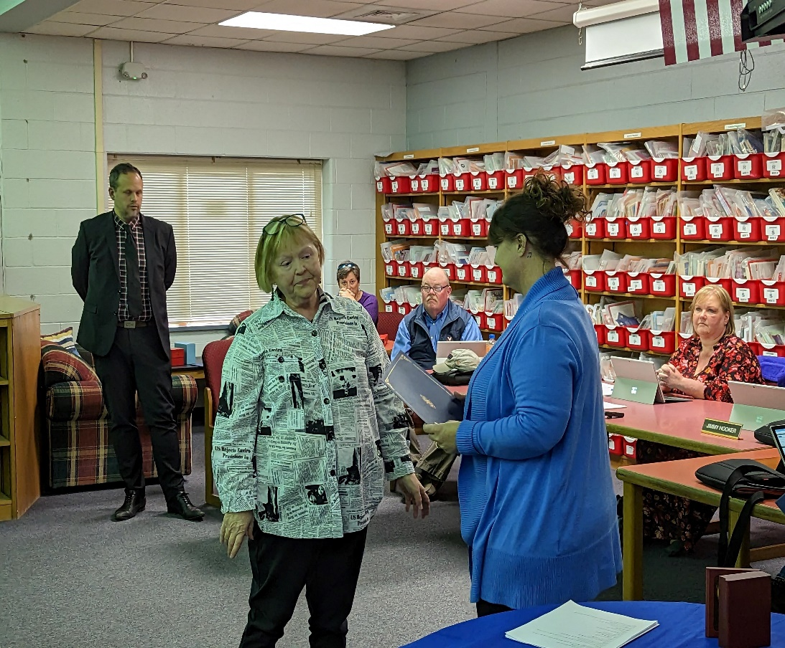
Mrs. Chapman
Retiring After 43 Years of Service

